Don’t Be Schooled by your kids | - THE E-CIG  - EPIDEMIC FORUM
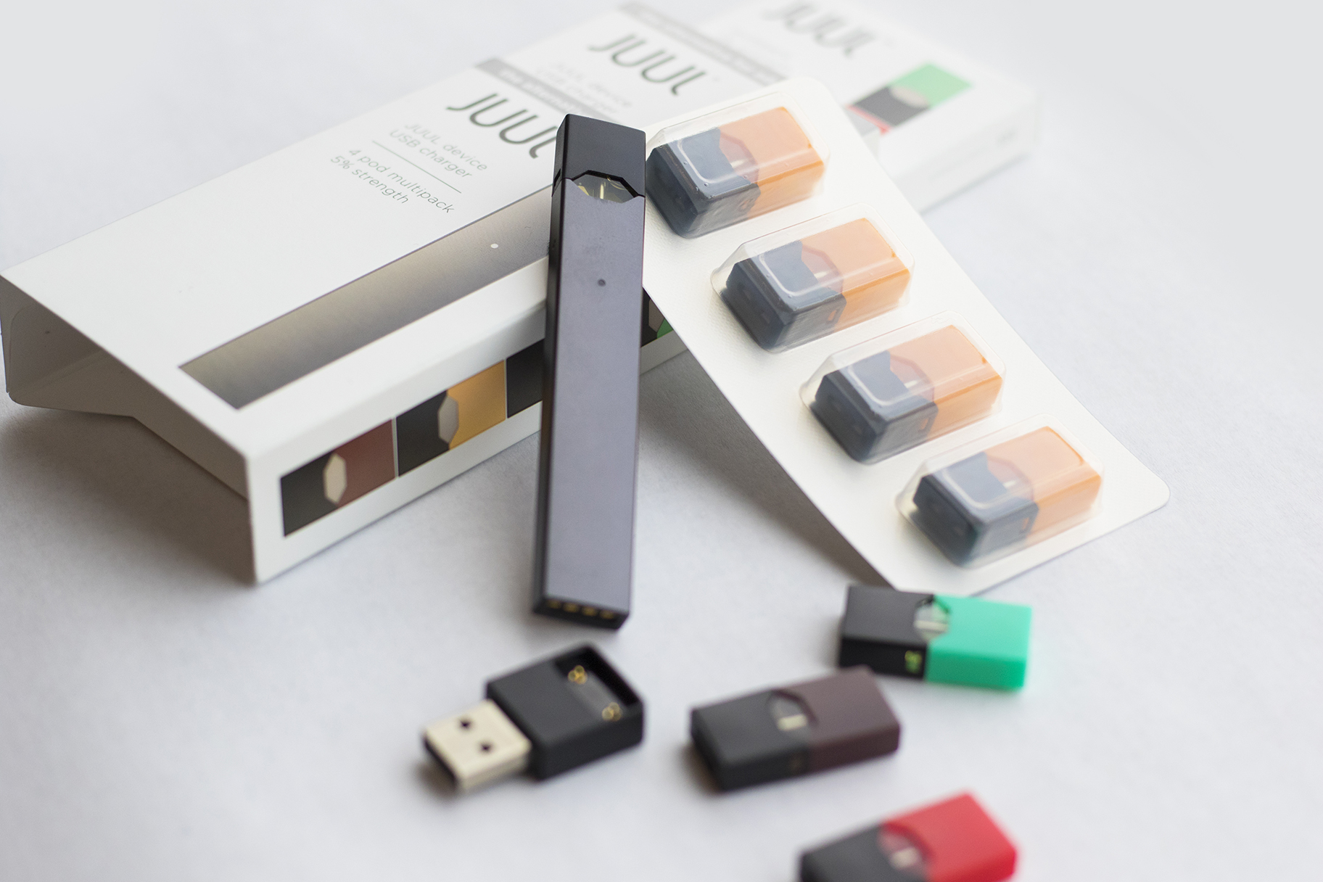  What do you know about the JUUL? Did you know that ALL JUUL pods have nicotine in them? Does this look like the next generation of addictive tobacco products? Do you happen to know what chemicals are in each JUUL pod? How are youth able to smoke THC from a JUUL/ e-cig? What other e-cigs are out there? What is the latest concerning the lung diseases and deaths with vaping?  Answers to these questions and so much more will be discussed.  Sponsored by: Deerfield Cares Coalition  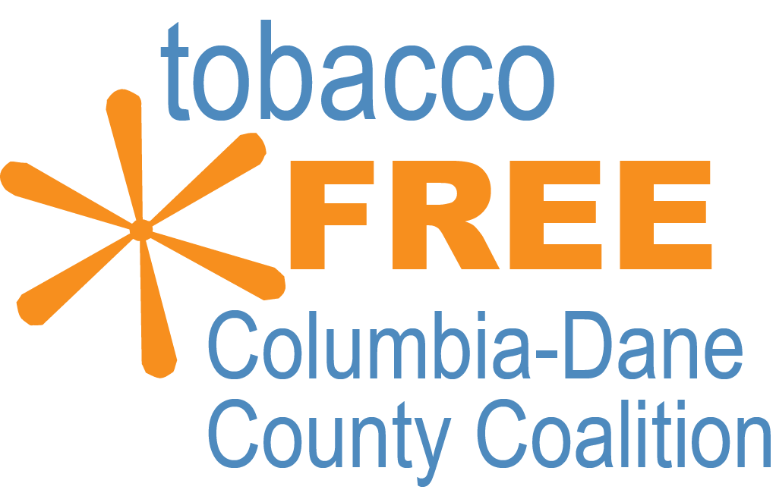 | 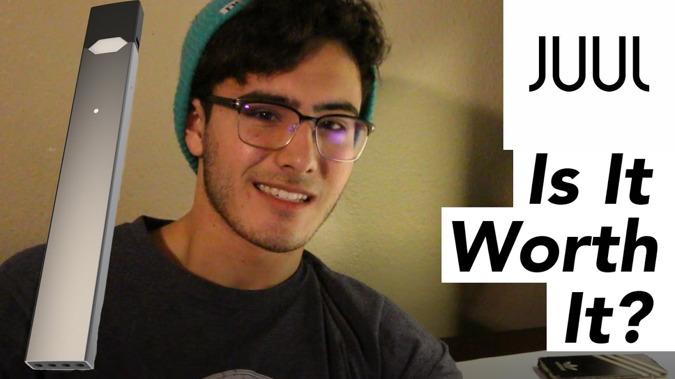  WHEN: NOVEMBER 18 2019 6:30-8:00PM  WHERE: Deerfield Community Center  Guest Speaker: Ryan Sheahan, Public Health Madison and Dane Cty.  With the rise in use of the JUUL among the youth of the Deerfield community this is an important, informational forum.  This is being offered to all parents, grandparents, adults in the community.

